

**Cell Phone Detector**

**Submitted by:**

|  |  |
| --- | --- |
| **Name of student** | **Roll no.** |
| Faizan Azam | 2019-EE-381 |
| Muhammad Asad | 2019-EE-383 |
| Asad ul Rehman | 2019-EE-389 |
| M Bilal Nawaz | 2019R2017-EE-421 |

**Submitted to:**

Mam Munazza Sadaf

**Dated:**

03-15-2021

* **Introduction:**

Cell phones have become an integral part of people’s lives. They are not only used for communication via short messaging service (SMS), calls, emails and internet but advanced applications such as remote health monitoring systems and security systems have been integrated with mobile phones. The recent years have seen rapid advancements in the value addition applications in mobile phones such as high definition cameras and high speed internet connectivity. The country has also experienced developments in the infrastructures to support the rising need of faster internet connectivity. Safaricom rolled out their 4G internet infrastructure which is now available in over thirteen towns in the country. Despite the advantages enjoyed by these advancements in mobile technology, there are threats that have been posed by their usage. Company data mining has been a big threat in the industry where employees are able to access sensitive company information and share with the competitors. This led to the development of cell phone jammers where signal reception is completely blocked when you enter the premises. Despite personal privacy invaded by the usage of such devices, this could not put to an end the vice since mobile phones could be connected to the computer and information transferred and sent when the employee is out of the company premises. Criminal activities and attempted escape incidences have been organized by inmates in correctional institutions through the use of mobile phones in such facilities. The most common incidence in the country is when people were conned by inmates who impersonated promoters and required winners to send money as fees to facilitate the award of prizes. Life support machines are also sensitive to the use of mobile phones. The use of mobile phones in such a facility leads to adverse repercussions to the life of persons whose lives depend on the proper functionality of the machines. Other places are Airplanes, petrol stations, conference halls, examination halls, worship centers, etc. where the use of mobile phones can either lead to failure of sensitive machines or is a nuisance.

* **Contents :**

Contents are following:

* Objectives
* Material required
* Working
* Circuit diagram
* Applications
* Results
* **Objectives**

1. To design a Cell phone detector that detects the presence of mobile phone signals.
2. Design a circuit that can detect signals in the range of 0.9GHz to 3GHz.

* **Material Required**
* **Components:**
* CA3130 Op-Amp
* Resistors – 2.2MΩ x 2, 100KΩ, 1KΩ
* Capacitors – 22pF x 2, 0.22nF, 47pF, 100µF
* BC548 NPN Transistor
* LED
* Connecting Wires
* Breadboard
* 9V Battery
* **Theory & Working**
* RF signal**>**CA3130 Op-Amp**>**Transistor**>**LED.

The [cell phone detector](https://phantom-technologies.com/cell-phone-detector/) is a technological device that detects the presence and existence of cell phones in an area or within a stipulated range of operation. Once this cell phone detector detects the presence of a cell phone, the phone detector system raises the alarm and speak to the mobile phone user to switch it off. The cell phone detector has different ways of alerting the user of the phone; it does this by either sending an alert message, a single beep of the detector or ringtone. The operator of this device can record a voice message or write a customized text message that will be sent to every phone detected. This is a great way to prevent the use of cell phones in examination halls, worship sites, private rooms, etc. The use of the cell phone detector is also one of the ways of [managing cell phones in the classroom](https://phantom-technologies.com/managing-cell-phones-in-the-classroom/).

The cell phone detectors are not only meant to be used to discover mobile devices that are in the conversation mode alone, but they can also be used for those that are in standby mode or switched on generally. Since it is not always possible to check everybody entering sensitive places like worship places, libraries, or any strategic site, the use of a cell phone detector will be important in such places. They can be used as rescue devices, and the authorities will use them to clear out all the unwanted things

**How does a mobile phone signal detector work?**

* The circuit can detect the incoming and outgoing calls, SMS and video transmission even if the mobile phone is kept in the silent mode. The moment the Bug detects RF transmission signal from an activated mobile phone, it starts sounding a beep alarm and the LED blinks. The alarm continues until the signal transmission ceases.

**How do cell phone capacitors work?**

* The capacitors collection are used to detect RF Signals when a cell phone makes (or receives) a phone call or sends (or receives) a text message. Op-Amp reads the signals by converting the rise in current at input to voltage at output and the LED will be activated.

**How does a mobile phone RF circuit work?**

* The circuit uses a 0.22μF disk capacitor to capture the RF signals from the mobile phone. This part should be like an aerial, so the capacitor is arranged as a mini loop aerial. In short with this arrangement the capacitor works like an air core with ability to oscillate and discharge current

**What is the use of cell phone detector circuit?**

* Cell Phone Detector Circuit Applications. This circuit can be used at examination halls, meetings to detect presence of mobile phones and prevent the use of cell phones. It can be used for detecting mobile phones used for spying and unauthorized transmission of audio and video. It can be used to detect stolen mobile phones.

**BiCMOS Op-Amp:**

The CA3130 is an operational amplifier with MOFSET.

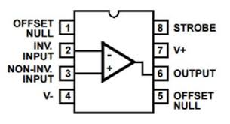

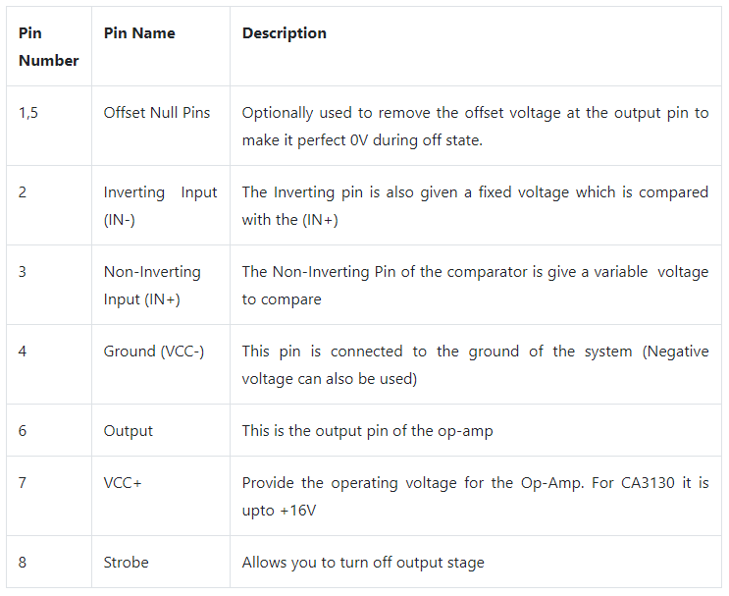

The **CA3130** are op amps that combine the advantage of both CMOS and bipolar transistors.

A CMOS transistor-pair, capable of swinging the output voltage to within 10mV of either supply-voltage terminal (at very high values of load impedance), is employed as the output circuit.

**BC548 Transistor:**

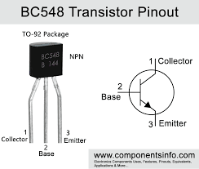

**BC548** is a **NPN transistor** so the collector and emitter will be left open (Reverse biased) when the base pin is held at ground and will be closed (Forward biased) when a signal is provided to base pin. **BC548** has a gain value of 110 to 800, this value determines the amplification capacity of the **transistor**.

**BC548 transistor** is **used** for amplifying and switching purposes in electrical circuits. Like every other NPN **transistor**, it consists of three pins: the collector, base, and emitter.

**Circuit diagram:**

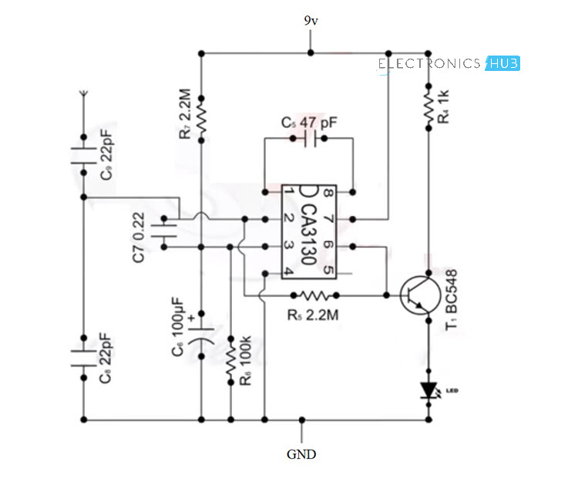

This is the actual circuit diagram that we will implement on BreadBoard to build up this project.

**Circuit:**

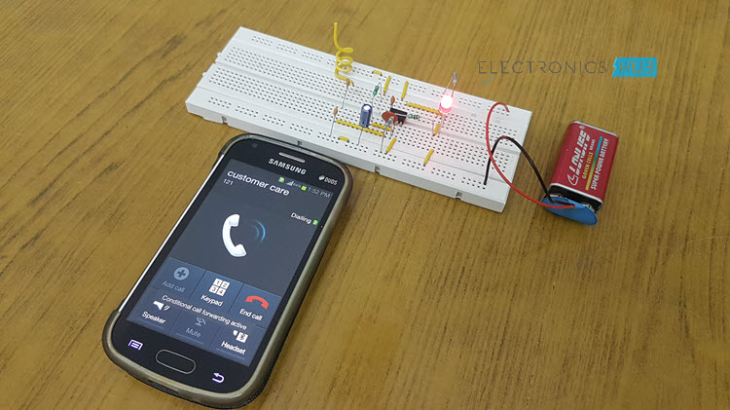

**Applications:**

Its applications are as follows:

1. This circuit can be used at examination halls, meetings to detect presence of mobile phones and prevent the use of cell phones.
2. It can be used for detecting mobile phones used for spying and unauthorized transmission of audio and video.
3. It can be used to detect stolen mobile phones.

### **Limitations of Mobile Phone Detector Circuit:**

1. It is a low range detector, of the order of centimetres.

